**Talking about work-life balance**

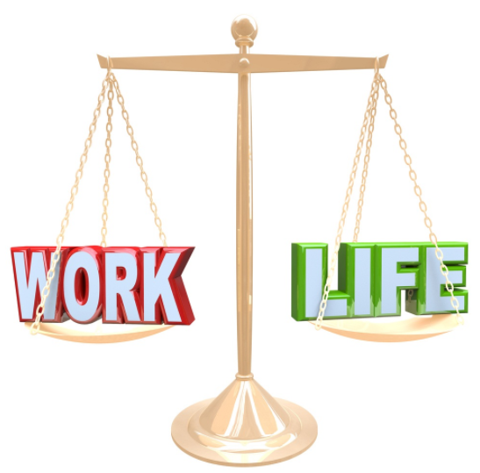

**Lead-in. A. Listen to the** [**recording**](https://epam-my.sharepoint.com/:u:/p/iryna_pikta/ETqI3HrNWKFIpyRa0OZeUGMBMRU_U-Bko33-YRYqDB8dWw?e=Ra21BA) **and write down the questions.**

1. …………………………………………………………………………………………………………?
2. …………………………………………………………………………………………………………?
3. …………………………………………………………………………………………………………?

**B. Discuss the questions with a partner.**

**Task 1 A. Complete the scale with the adverbs of frequency from the list.**

* ***constantly***
* ***always***
* ***sometimes***
* ***occasionally***
* ***usually***
* ***normally***
* ***frequently***

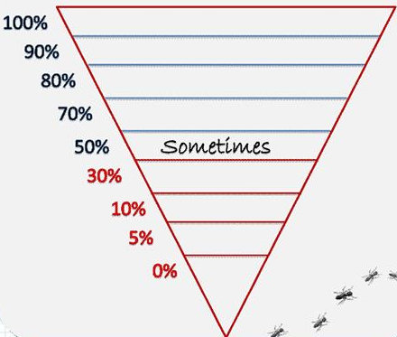

* ***rarely***
* ***seldom***
* ***often***
* ***never***
* ***hardly ever***
* ***regularly***

**Task 1 B. Read the sentences in the Grammar boxes. Answer the questions (1-3).**

**Adverbial phrases**

1. **Most days** I am extremely busy.
2. I write reports and attend meetings **every day**.
3. **Once in a while** she phoned him.
4. We have some issues **from time to time.**
5. **The Board of Directors meets once a month.**

|  |
| --- |
| **Adverbs of frequency**   1. I **usually** advise them on equipment. 2. People in these situations **often** have no confidence. 3. I **always** try to make them feel more confident. 4. They are **always** really greateful. 5. I **rarely** get home before 6.30 in the evening. |

**Answer the questions:**

1. Where do adverbs of frequency (*usually, often, etc.*) go in relation to the **main verb**?
2. Where do adverbs of frequency go in relation to the verb **be**?
3. Where do adverbial phrases (*most days, every day, in the evening*) go in the sentence?

**Task 2. Put the words in the correct order to make sentences.**

1. by 8.00 in the morning/’m/usually/I/at work ……………………………………………………………………………………….
2. rarely/my boss/checks/my work ……………………………………………………………………………………………………
3. every now and again/he/does overtime …………………………………………………………………………………………..
4. always/my emails/before I send them/check/I ……………………………………………………………………………………
5. don’t/people in my country/late/work/usually …………………………………………………………………………………….
6. on Fridays/wear/casual clothes/people/frequently ………………………………………………………………………………
7. tidy/once in a while/I/my desk ……………………………………………………………………………………………………..
8. home with me/hardly ever/I/take/work ……………………………………………………………………………………………

* **Are any of the statements above true for you?**

**Task 3 A. Take a quiz below to find out if you have a healthy work-life balance, or if your job (or your personal life) is taking over. Just answer (T) for "true" or (F) for "false".**

1. ___My work schedule is **often** jam-packed.
2. ___Someone else **usually** has control over my work schedule.
3. ___I **occasionally** look stressed out.
4. ___I **frequently** spend a lot of time responding to personal emails and phone calls when I am at work.
5. ___I **usually** have time to exercise in a gym.
6. ___I **always** plan the activities that help me to recharge and boost my energy level.
7. ___ I sleep less than 8 hours per night **on a regular basis.**
8. ___I **frequently** make personal calls while I’m at work.
9. ___I make mistakes on the job **increasingly often**.
10. ___**Once in a while** I check my phone and email when I leave work.
11. ___It is **normally** hard for me to shift the focus of my attention.
12. ___I **never** worry a lot about how I'll get everything done.
13. ___I **hardly ever** work more than 40 hours a week.
14. ___I **rarely** lose my temper.
15. ___I **usually** don't have enough time to relax.
16. ___I **frequently** waste my time on social media sites.
17. ___I am tired **all the time**.
18. ___I **always** put family activities in my calendar.
19. ___I **normally** keep away from the colleagues who do nothing but gossip.
20. ___I drink more than 3 cups or shots of caffeinated drinks **every day**.

* **Do you agree with your results?**

**Task 3 B. Make the F (False) sentences from Task 3 A true for you. Rewrite them.**

_____________________________________________________________________________________________________________________________________________________________________________________________________________________________________________________________________________________________________________________________________________________________________________________________________________________________________________________________________________________________________

__________________________________________________________________________________________________________________________________________________________________________________________________

_________________________________________________________________________________________________

**Task 4 A. Mark the statements below as true or false. Compare your ideas in pairs. Explain your choice.**

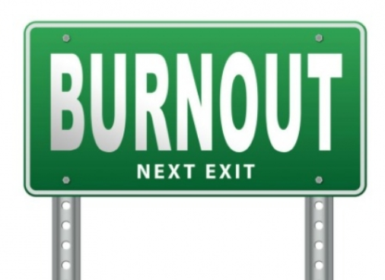

1. People **usually** work long hours because they are worried about their jobs. ____
2. Employees might **sometimes** ignore personal interests if there is a poor work-life balance. ____
3. Only the company is **normally** responsible for overwork. ____
4. All employees should have flexi time and access to recreation facilities. ____

**Task 4 B. Read the text and check the answers.**

Work-life balance is to the balance between a person's career and his personal life. Many people work longer hours and use fewer vacation days because of globalization, outsourcing, and a loss of job security. As a result, employees have less time for personal interests, personal development, and family. They suffer from reduced productivity, depression, high levels of stress, and [**burnout**](https://dictionary.cambridge.org/dictionary/english/burnout).

Although the employee makes the choice to work longer hours, the corporate culture is also responsible. Companies should educate their workers on the importance of a healthy work-life balance. It's also helpful to provide flexi time, maternity and paternity leave, telecommuting, or even recreation facilities. If they don't, people will become money-rich but time-poor.

* **Do you agree with the information. Why / not?**

**Task 5. Discuss the questions with a partner. Remember to support your answers with examples. Use the adverbs of frequency and adverbial phrases in brackets to answer the questions.**

1. Do you find your job stressful? Why / not? **(hardly ever; infrequently; occasionally)**
2. How do you relax in the office? **(regularly; seldom; normally)**
3. What do you do to make sure you have a good work-life balance? **(often; from time to time; regularly)**
4. What do you do to deal with stress? (**once in a while; never;** **usually**)
5. How can EPAM employees avoid burnout? (**often; occasionally; always)**
6. ‘EPAMers are constantly under pressure to complete their tasks in less time.’ Do you agree? Why / not? (**once in a while; most days; frequently)**